Introduction to Data Structure

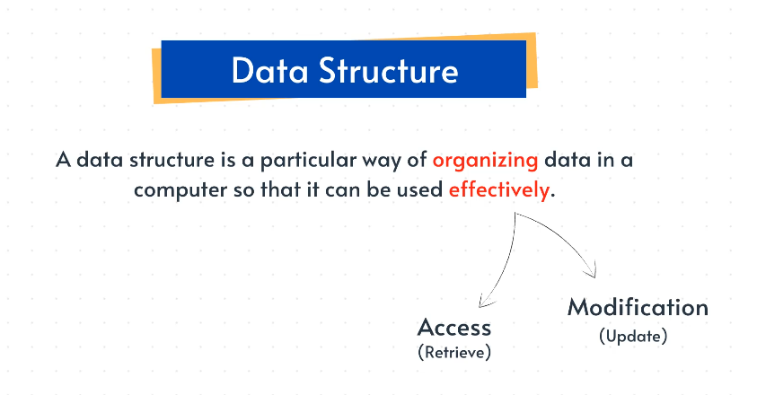

Type of Data Structure :

1. Primitive Data Struc. (predefined way of storing data)

e. g . Integers , Float , Characters , Pointers

1. Non-primitive data Struc. (user-defined way of storing data)

1. Linear data struc. - sequential

e .g :

1.Array

2. Stacks

3. Queue

4. Linked List

2. Non-Linear data struc. - non-sequential

e. g .

1. Graphs

2. Trees

Array :

Items are organized sequentially (one after another ) in memory slots .

Types of Array :

1. Static - Fixed number of memory slots .
2. Dynamic - Flexible number of memory slots .

Common Operations on Array :

1. Access
2. Update
3. Traversal
4. Search
5. Delete
6. Access :

Time Complexity : O(1)

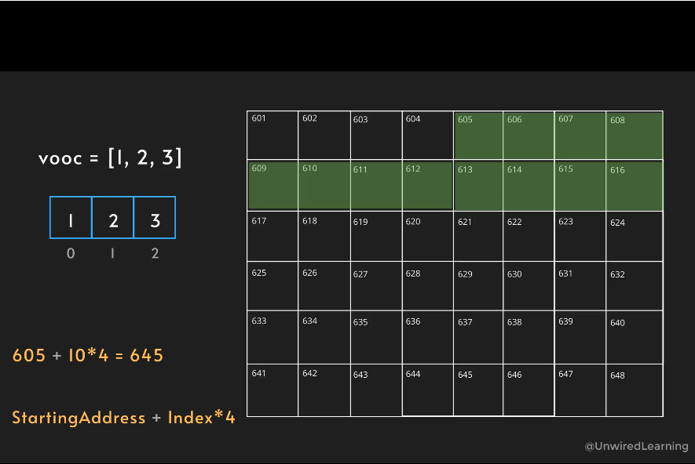

1. Update :

Time Complexity : O(1)

1. Traversal : ( visiting each and every element of array )

Time Complexity : O(n)

1. Searching : (Find a particular elements )

Time Complexity : O(n)

1. Copy : (copying complete array to new memory address )

Time Complexity : O(n)

1. Insertion :

Type :

* Beginning
* End
* Middle

Time Complexity :

For ,

Static Array : O(n)

Dynamic Array : O(1) or O(n)

1. Deletion :

Type :

* Beginning —--> O(n)
* End —---> O(n)
* Middle —--- > O(1)

Array Time Complexity In Different Operations

| Access | Search | Insertion | Deletion |
| --- | --- | --- | --- |
| O(1) | O(n) | O(n) | O(n) |